**Marine Engineering**

There are 8 Workshops in operation:

* Engine,
* paint,
* electric,
* ship building,
* mechanical,
* molding & forging,
* Fitting
* Wielding

**Workshop process:** plz, see the process diagram

**3 Slipways: capacity**

* 50Ton,
* 120 Ton,
* 1200 ton

**Sub-store:**

1 sub-store (for spare parts)

**Repair & Maintenance:**

* Scheduled Maintenance – every three months
* On-demand maintenance

**SMS & E-mail reminder**

* Reminder for schedule
* Job completion notification

**_____________________________________________**

**Integration:**

* Craft Management module - for vessel information
* Inventory module – for spare parts

**MW Work Process:**

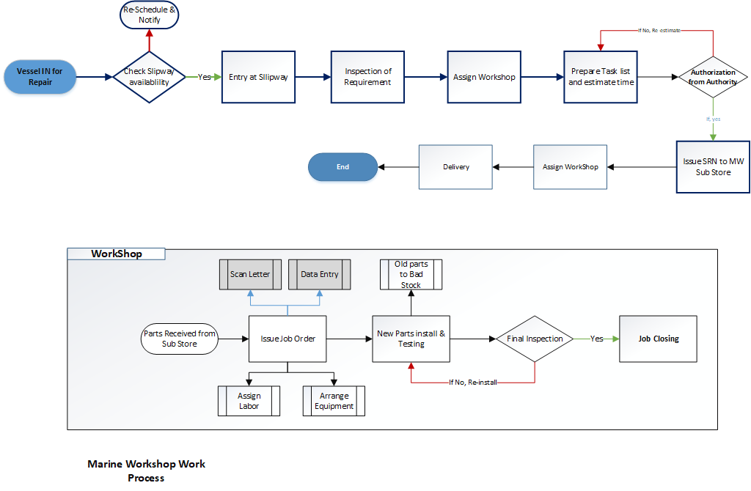



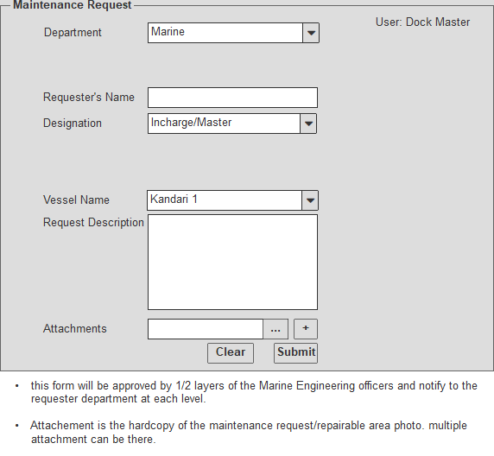

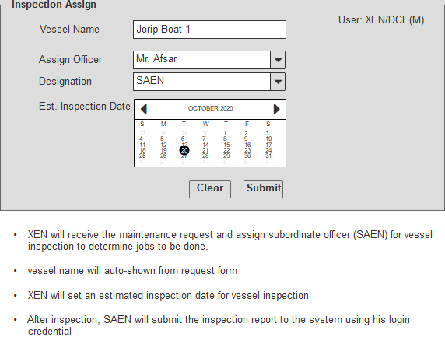

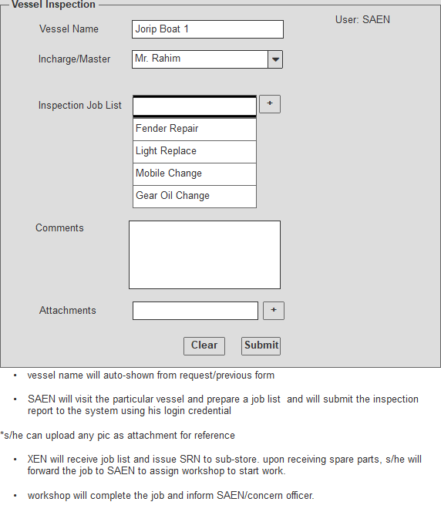

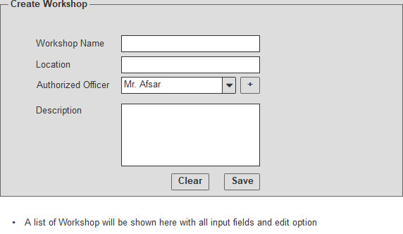

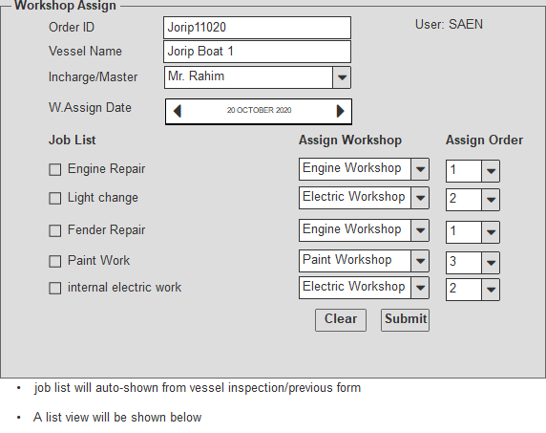

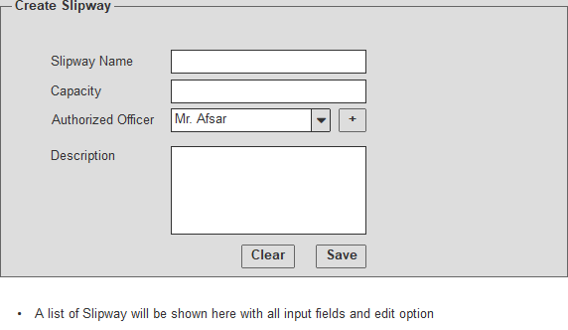

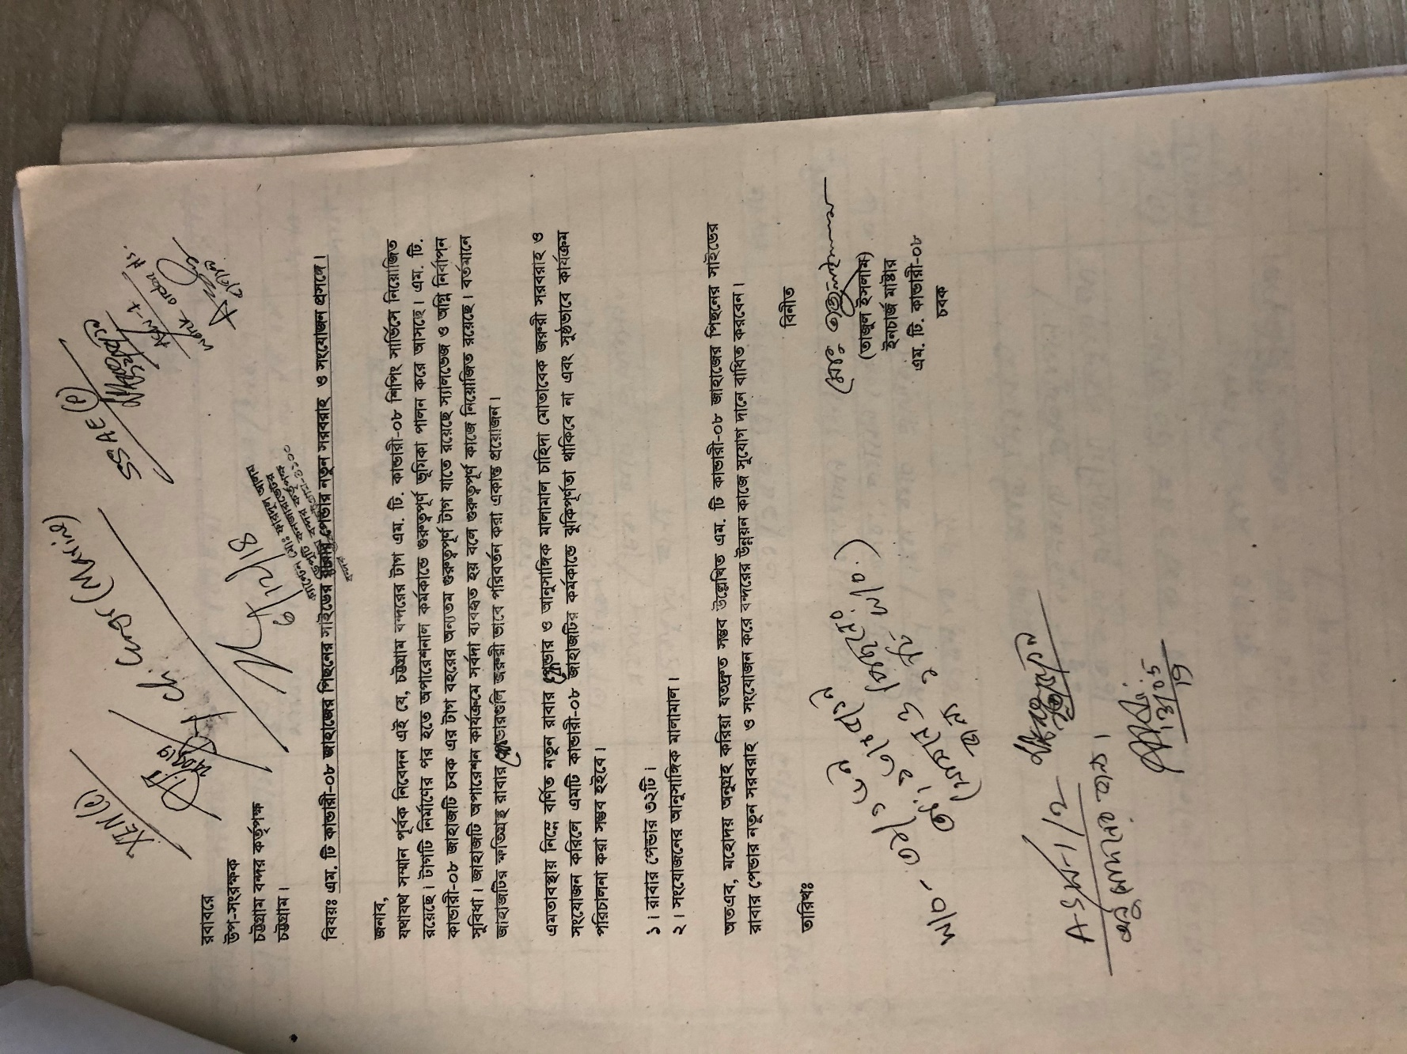

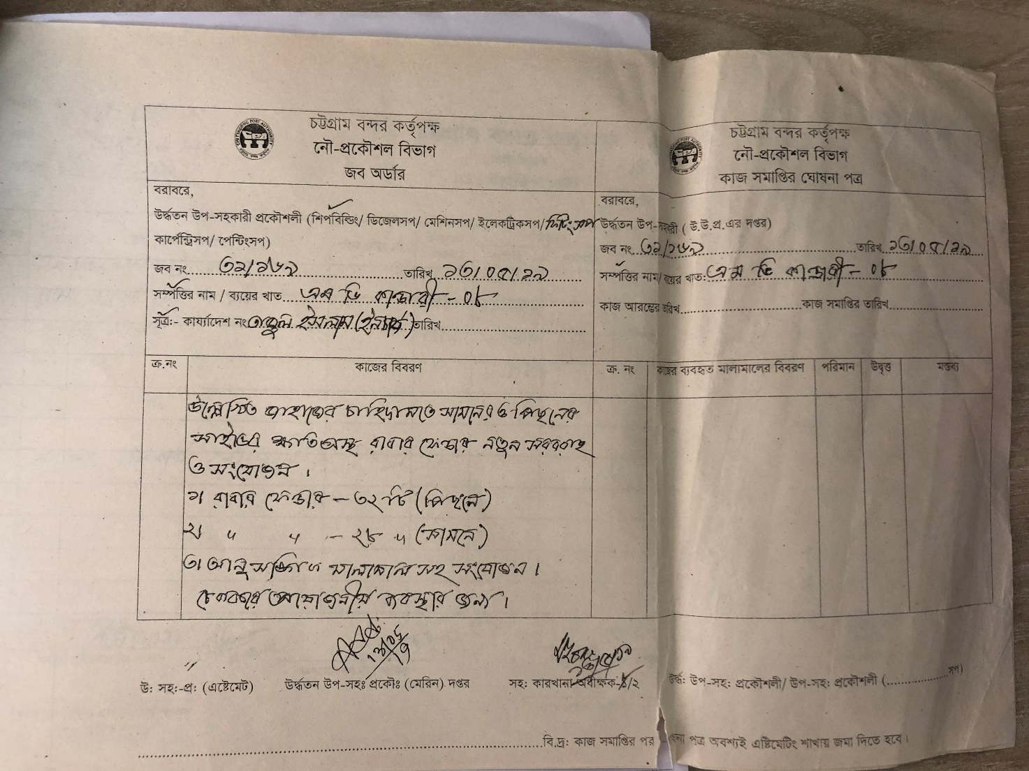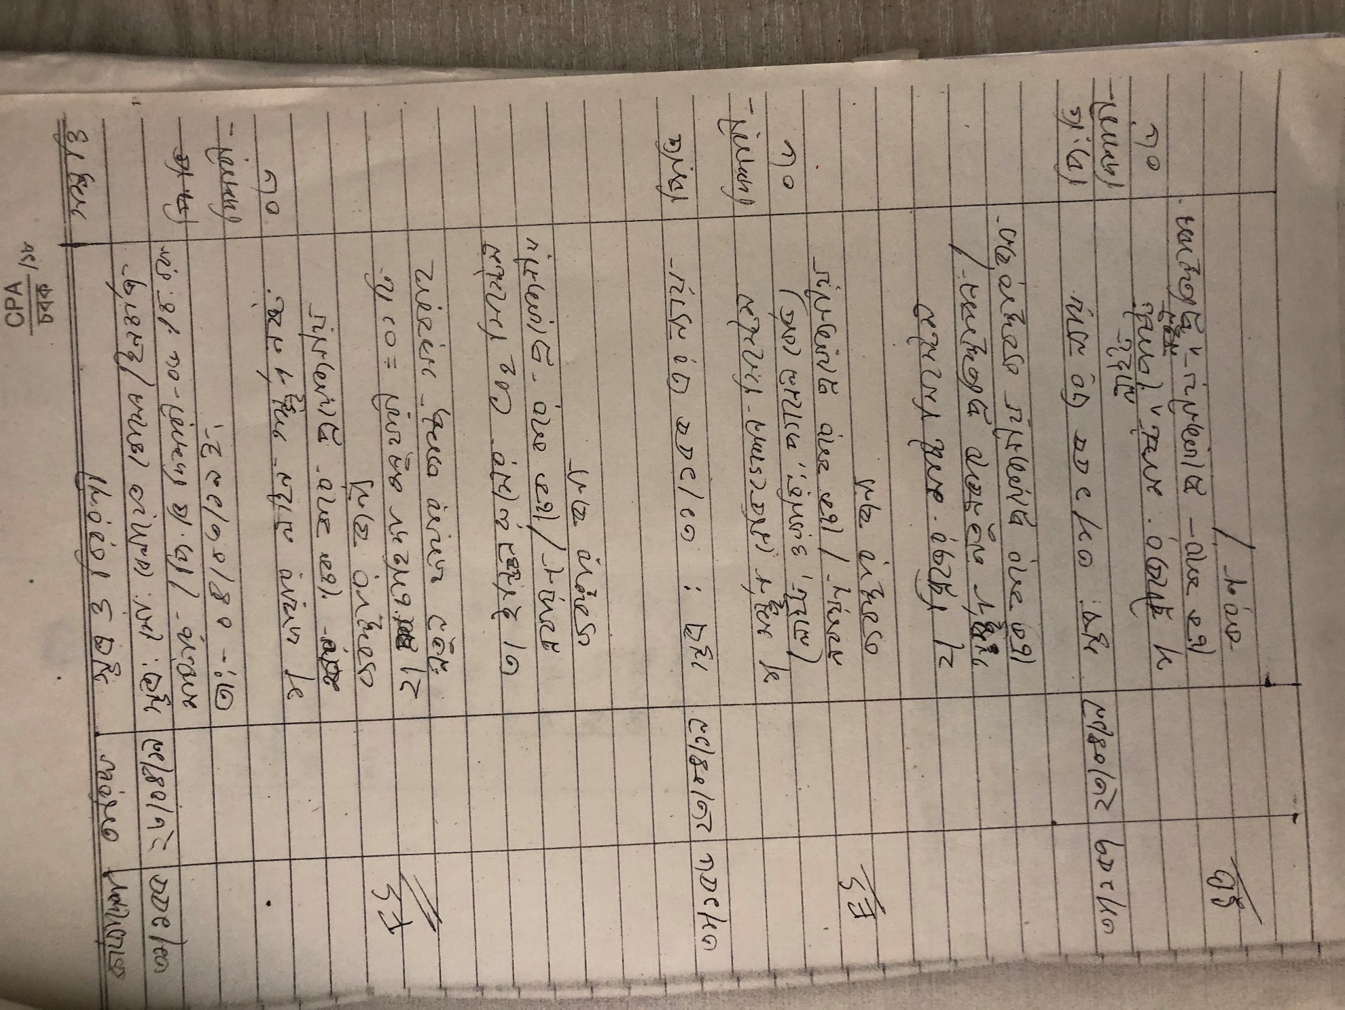

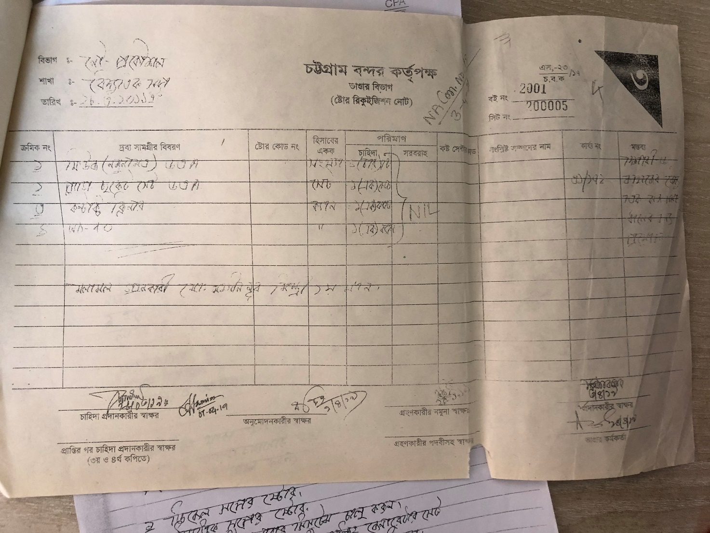

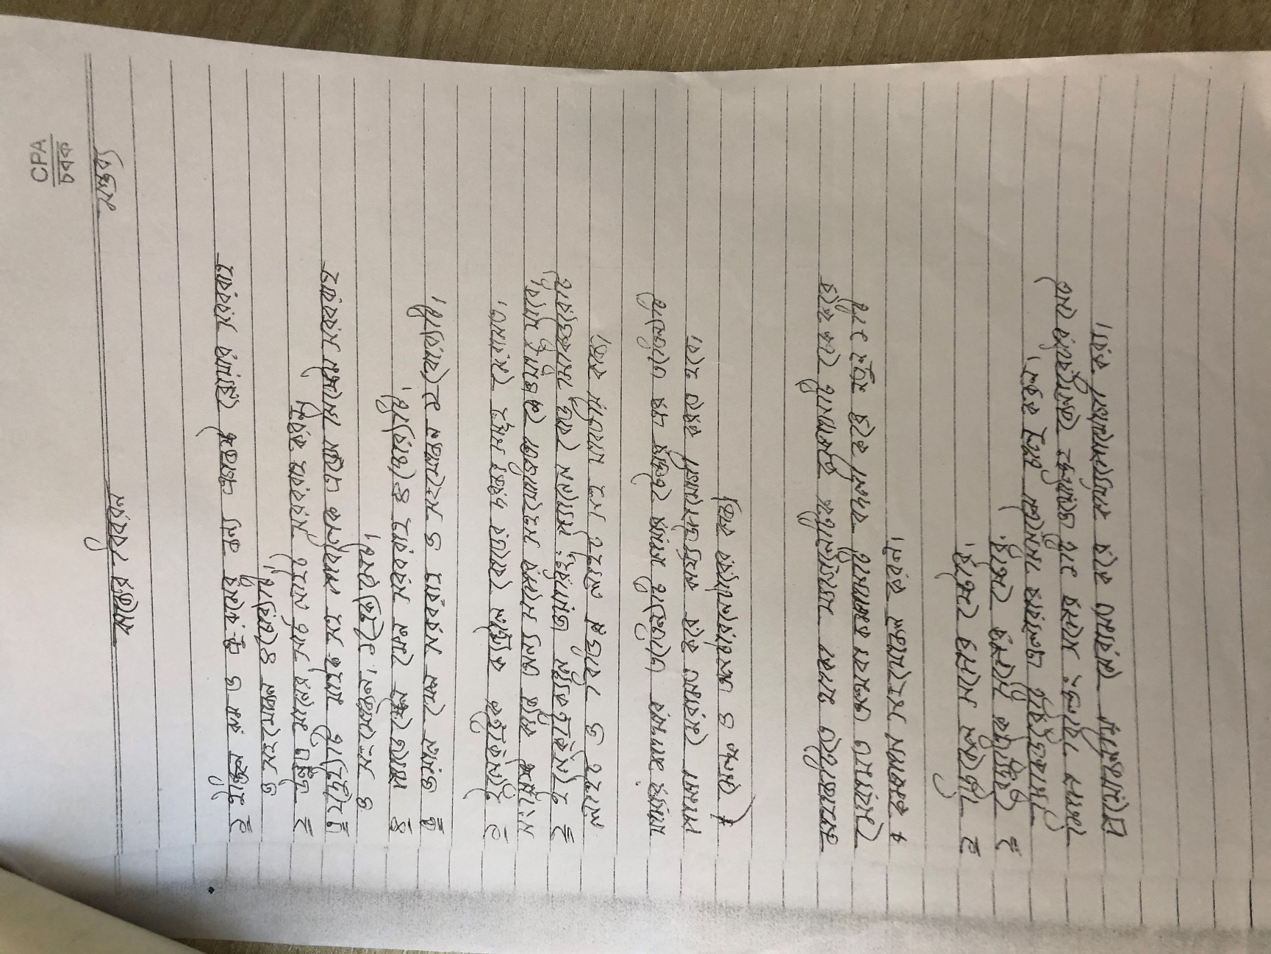

NO Need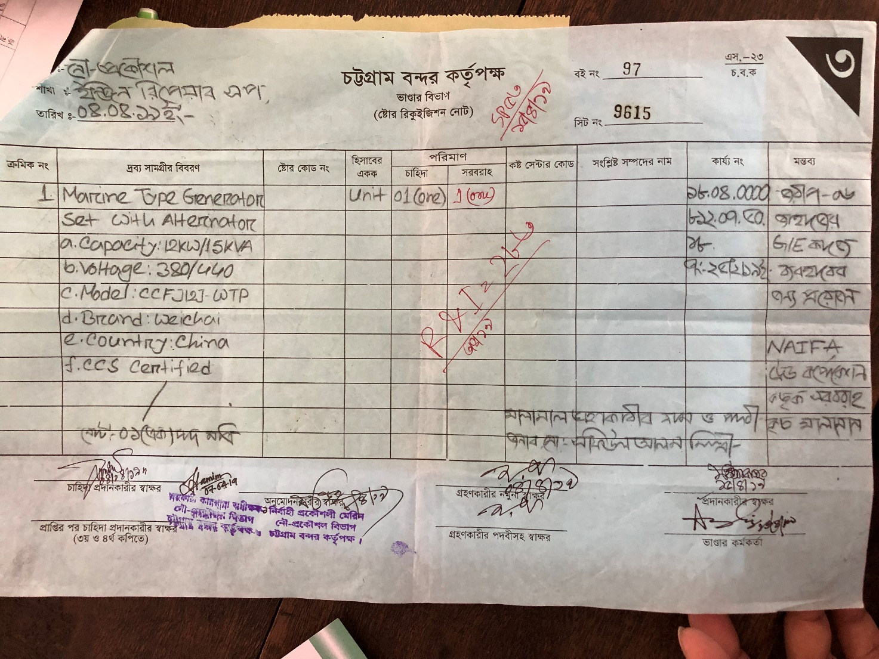

No need